Name: Arnav Upperwal
SAP ID: 590027436
Batch 45

1. Check whether the given number is divisible by 3 and 5 both.
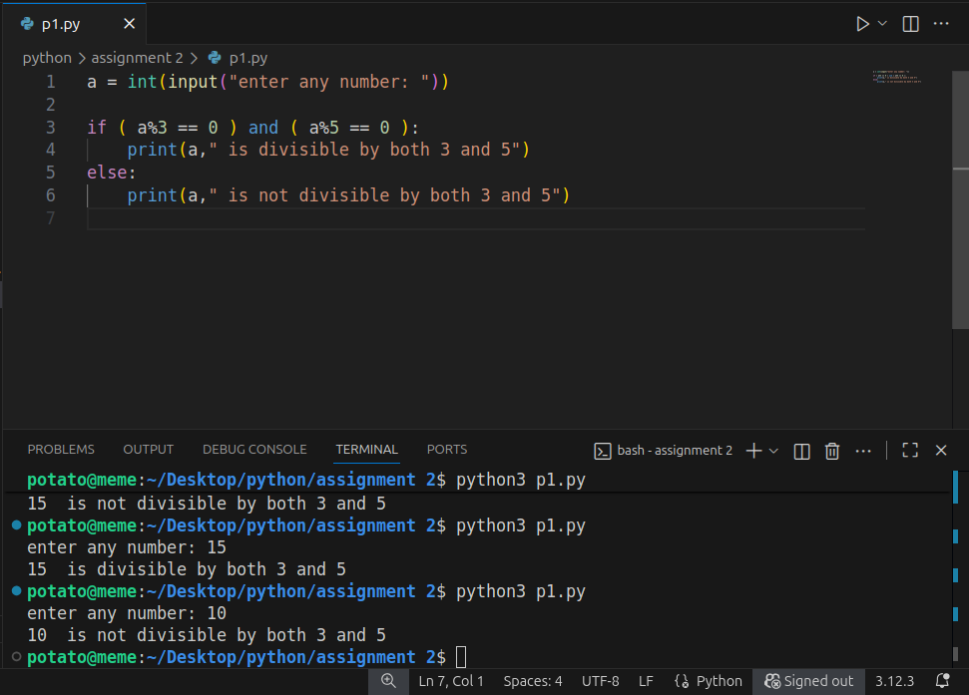
2. Check whether a given number is multiple of five or not.
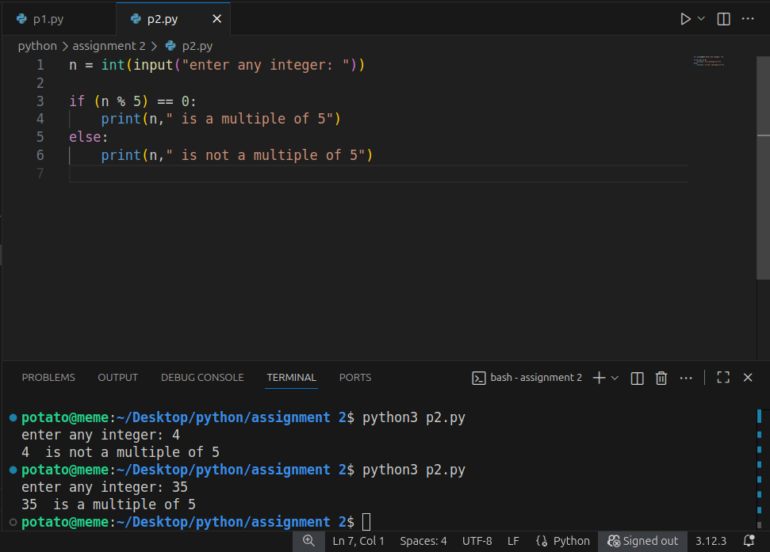
3. Find the greatest among the two numbers. If numbers are equal than print “numbers are equal”.
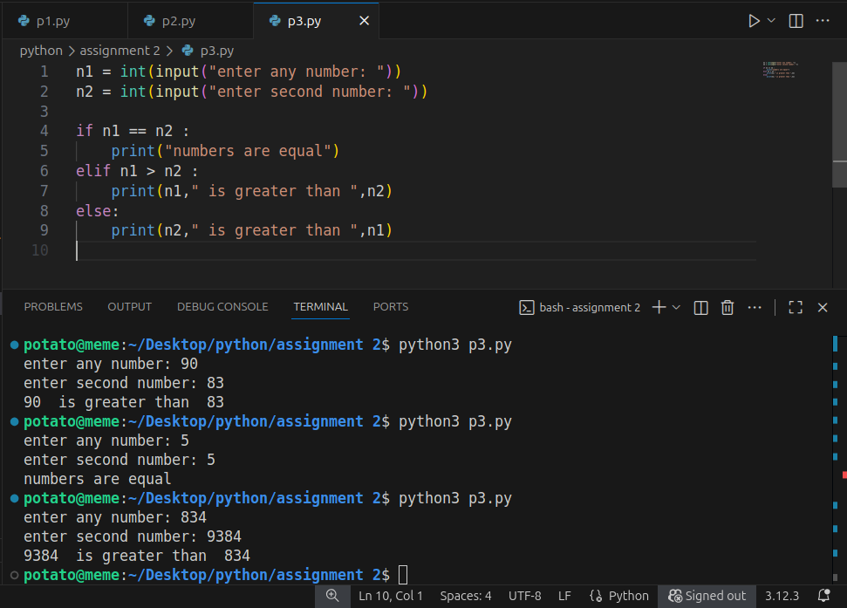
4. Find the greatest among three numbers assuming no two values are same.
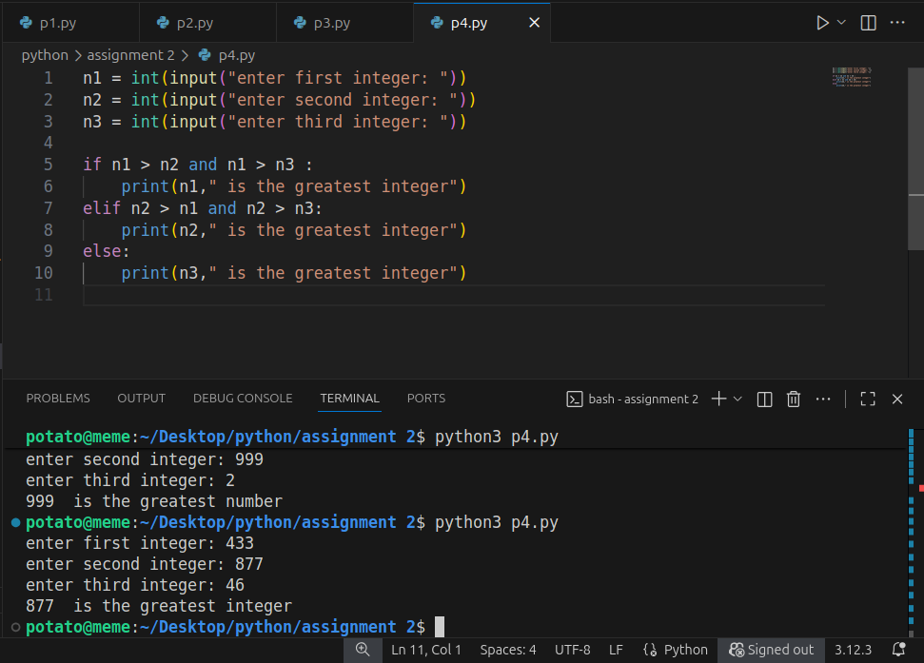
5. Check whether the quadratic equation has real roots or imaginary roots. Display the roots.
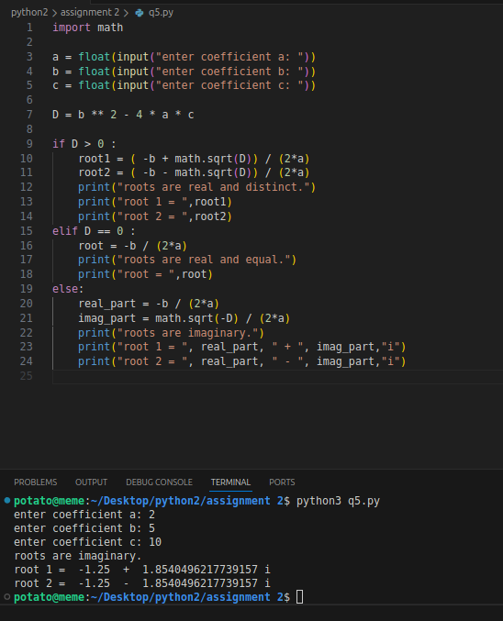
6. Find whether a given year is a leap year or not.
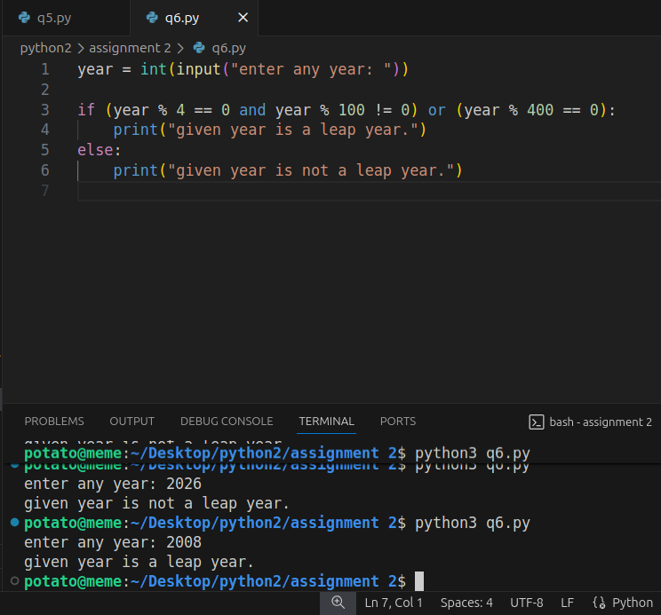
7. Write a program which takes any date as input and display next date of the calendar
e.g.
I/P: day=20 month=9 year=2005
O/P: day=21 month=9 year 2005
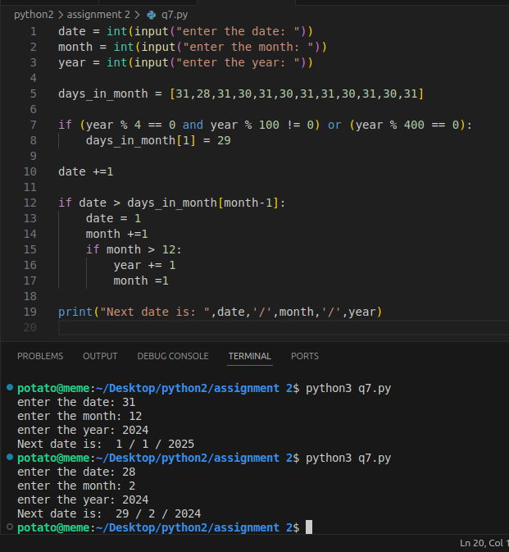
8. Print the grade sheet of a student for the given range of cgpa. Scan marks of five subjects and calculate the percentage.
